ZOUJIN AFRICA SAFARIS LIMITED
Internet business Centre
Building No. 22 plums lane off ojijo road parklands, Nairobi-Kenya
P.O Box 659-00618, Ruaraka, Nairobi-Kenya
Mobile; +254721278538.

Day 1: Nairobi / Arrival
On arrival, you will be picked up at the airport after all immigration procedures are done, and transferred to your hotel.
Dinner and Hotel Four Point Sheraton Hotel
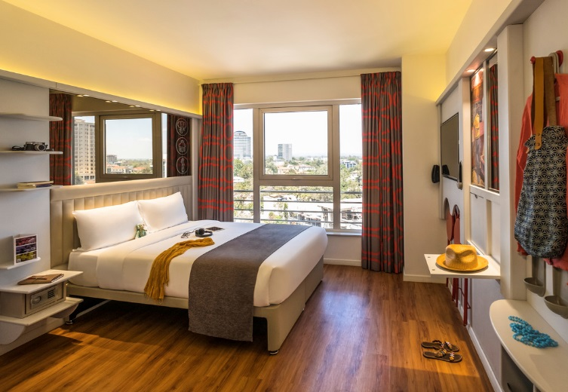

Day 2:Nairobi-Amboseli
After breakfast depart for Amboseli arriving in time for lunch.
Afternoon game drive with dinner and overnight at Amboseli Serena Lodge.

Day 3: Amboseli
Full day spent in Amboseli with morning and afternoon game drives.
All meals and overnight at Amboseli Serena Lodge.

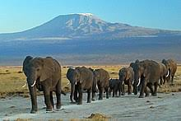
Day 4 :Amboseli -Lake Naivasha
After breakfast depart for Naivasha with lunch at Nairobi later proceed to Naivasha arriving in the afternoon hours where you will have activities like boat ride,. Visit to the crescent island all at an extra cost.
Diner and overnight Lake Naivasha Country Club or similar
Day 5: Lake Naivasha Masai Mara
Depart for Masai Mara with packed lunch arriving in the afternoon hours with a game drive enroute.
Later check in to the Hotel for diner and over night at Tipilikwani Tented Camp
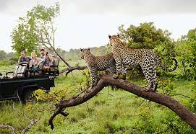

Day 6: Masai Mara
Full day spent in Masai Mara with morning and afternoon game drives.
Have a chance of visiting the Mara river to witness the seventh wonder of the world the famous Wild beast migration
also, you can visit the Maasai Villages to learn about their cultures but at an extra cost.
All meals and overnight Tipilikwani Tented Camp
You can as well take an option of a balloon Safari @450 Usd Per Person
Day 7: Masai Mara- Serengeti
After breakfast depart for Isebania boarder with packed lunch, transfer to the Kenya Tanzania Boarder where you will be introduced to our Tanzania Driver to take you on the Tanzanian Safari.
Depart for Serengeti arriving in the evening hours.
Check in your Hotel for freshening up and after that you will have your dinner and overnight a osinon Serengeti Tented Camp
Day 8 : Serengeti
Full days spent in Serengeti National reserve on either full day or morning and afternoon game drives.
All meals and overnight at Osinon Serengeti Tented camp
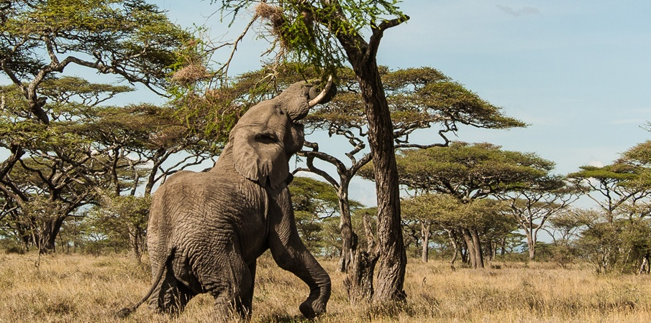

Day 9: Serengeti-Ngoro Ngoro
Depart after breakfast for Ngoro Ngoro with Packed Lunch. Upon arrival at Ngoro Ngoro you will have a visit at the Crater, spend the remaining part of the day there and later leave for
Your lodge before dusk.
Dinner and overnight at Ngoro Ngoro Farm House or similar
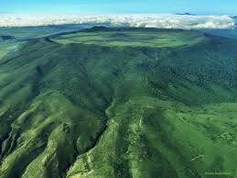

Day 10: Ngoro Ngoro-
Descend to the crater with packed lunch for the full day game viewing of the conservancy.
Diner and overnight Ngoro Ngoro Farm House or similar
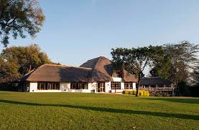

Day 11: Ngoro Ngoro -Arusha
Depart for Arusha with packed lunch upon arrival you will board the afternoon shuttle to Nairobi.
Dinner at Famous Carnivore Restaurant and later a transfer to for your outbound flight.

END OF SAFARI
Type of a vehicle | P.p.s based 0n 02 Pax | p.p.s based on 04 Pax | P.p.s based 0n 06 Pax
Mini Van | 4825Usd | 4105 | 3455
The Above Cost includes:
- One-night Accommodation on Half Board
- Lunch and dinner in Nairobi
- Return Transport by a minivan with a pop-up roof
- Accommodation in all lodges on Full Board
- Park Entrance Fee
- Game drives
- Shuttle from Arusha to Nairobi
- Two five hundred litres per day in the Van

Costs are current and subject to change and availability, do not include drinks, Laundry, Telephone calls Tips and personal gratuities.

Should you have any additional information you require please Do Not hesitate to contact us for clarifications.

Kind Regards,
Caroline

End of the Safari

BON VOYAGE!

