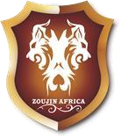

Zoujin Africa Safaris
Garden Estate off Thika road,
Building No. 35, Garden Upper Street, Nairobi, Kenya
P.O.BOX 659-00618, Nairobi Kenya.
Office Tel: +254721278538

Proposed Itinerary
Day 1: Nairobi/Arrival
Arrival at JKI Airport where you will be met by our team outside the customs and immigration halls and Briefed on your safari. Transfer to Four Points by Sheraton Airport Hotel for dinner & overnight.
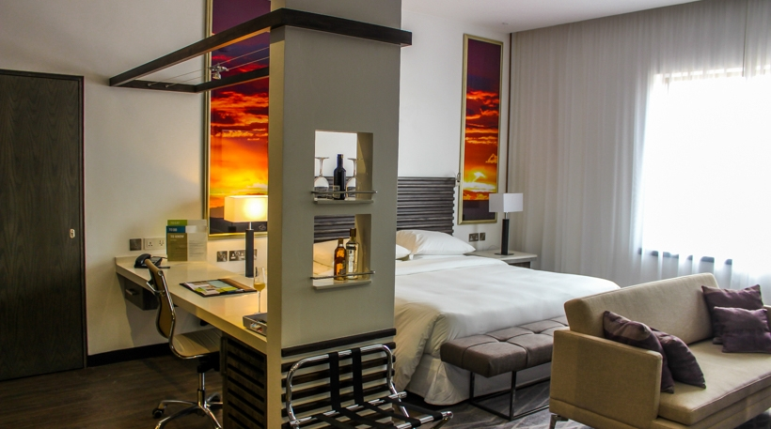
www.fourpointsnairobiairport.com
Day 2: Nairobi Excursion!
Breakfast, check out & pick up from your hotel at 0630hrs.Drive to Nairobi National park for an early morning game drive. The only National park in a city in the world. A glorious stretch of savannah set against the backdrop of Nairobi's glittering skyline; Nairobi National Park's relatively small size makes it all the easier to see all it has to offer in one day.
Later proceed to, Daphne Sheldrick Animal Orphanage, located in a secluded area of the Nairobi National Park, where orphaned baby elephants among other animals are taken care of by a dedicated team of conservationists. The tour starts from 1100hrs & ends at 1200hrs.
Lunch at Karen Blixen restaurant.
Later drive to Safari Park Hotel for check in. Spend the afternoon at leisure enjoying the hotel’s facilities.

Later go for the safari barbeque dinner at Nyama Choma restaurant located within the hotel.

Overnight at SAFARI PARK HOTEL.
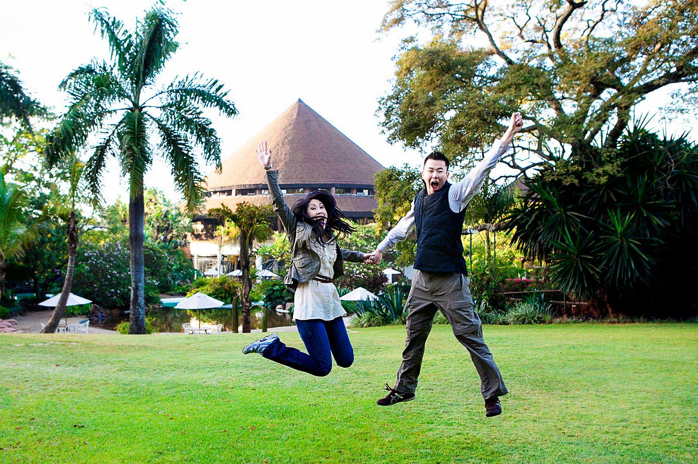
http://www.safaripark-hotel.com/

Day 3: Nairobi-Lake Nakuru National Park
Breakfast & drive to Lake Nakuru National park. Morning game drive at Lake Nakuru National park. Lake Nakuru National Park is a world class bird watching safari destination and fondly referred to as the bird watcher’s paradise the park has more than 25 black rhinoceros plus around 70 white rhinos. There are also a number of Rothschild's giraffe, Waterbuck, lion, cheetah and leopard. The park also has large sized pythons.
Later drive to LAKE NAKURU SOPA LODGE for check in & lunch. After lunch spend the rest of the afternoon at leisure & at 1600hrs proceed for an evening game drive.
Dinner & overnight.
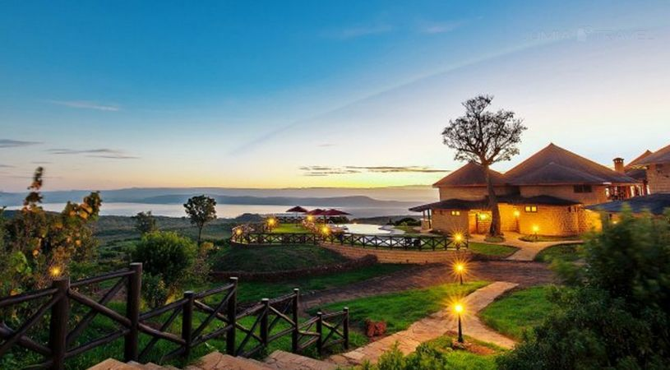
https://sopalodges.com/lake-nakuru-sopa-lodge/the-lodge

Day 4:Lake Nakuru National-Nairobi
Breakfast & drive to lake Naivasha for a boat ride.Lunch at Lake Naivasha sopa Lodge.Later drive back to Nairobi.
Dinner at Carnivore restaurant.Overnight at Norfolk Hotel.

Day 5: Depart

Breakfast & transfer to JKI Airport for departure flight home.

END OF SERVICE!

SPECIAL SAFARI COST

Valid Between 3rd January-31st March 2020 & 1st November-15th December 2020

Vehicle Type | 8 Pax | 10 pax | 12 pax | 20 pax | 30 pax | Single Room Supplement
Safari minivan | Usd 905 | Usd 875 | Usd 850 | Usd 845 | Usd 855 | Usd 240
Landcruiser | Usd 985 | Usd 940 | Usd 910 | Usd 900 | Usd 915 | Usd 240

Above Cost Includes
- Meet and greet services upon arrival
- Transfers as specified in the program
- Game drives on private basis in a Toyota land cruiser complete with a pop-up roof/minibus van with a pop-up roof.
- All accommodation and meals as specified in a standard room
- Full board accommodation on Safari
- Meals as stipulated in the itinerary
- Boat ride in Lake Naivasha
- All park fees and government taxes
- Complimentary 500ml mineral water per person per day in our vehicle only
- Our assistance.

Cost Excludes
- International flights
- Visas
- Airport tax (International)
- Guide or local escort gratuities
- Drinks and dining rooms tips, porterage, personal travel and baggage insurance
- Telephone bill, laundry and any items of a personal nature
- Masai village visit -$20
- Balloon safaris ride-$450
- Tips and gratuities-$10 per person per day

Additional remarks
- We may have to reroute the itinerary or accommodate in similar lodges in case of non-availability.
- Airport taxes or park fees may be changed without prior notice. This is beyond our control and any increase levied will be passed to you.

