Best of Kerala

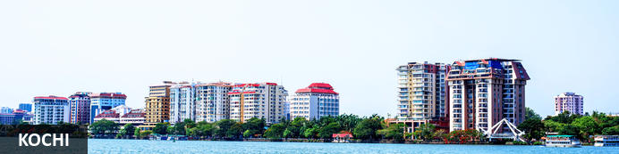
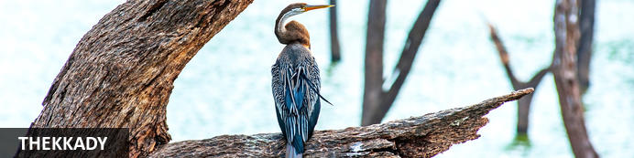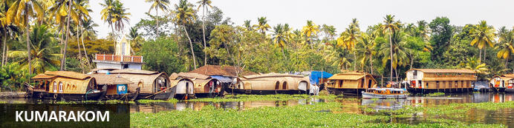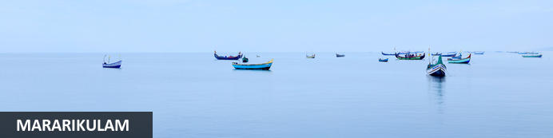

Best Of Kerala Tour
Cochin - Periyar – Kumarakom – Mararikulam
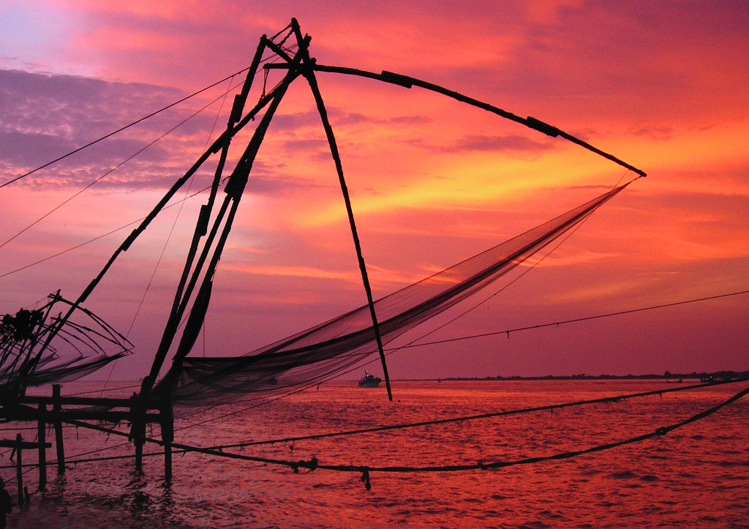
Day 01 - Arrival in Cochin
Your Best of Kerala tour starts with your arrival in to Cochin Airport, where you will be received by a Trans India Holidays representative and he will escort you to the Brunton Boatyard and will assist you with the check in formalities.

Cochin: - Widely known as the Queen of the Arabian Sea, Cochin has one of the world’s most attractive natural ports. Cochin is well known for its spices, silks, ivory and sandalwood. It has traditionally rich heritage, but at the same time it is one of the most fast-paced and contemporary cities in India. It is very easy to be spellbound by the magic of Cochin and it is the beauty and comparatively good infrastructure that makes Cochin the ideal gateway to the state. Cochin, or Kochi as it is now called, offers visitors palaces, museums, old churches, cool backwaters; palm fringed lagoons, beaches and the practicality of a modern metro city.

The Brunton Boatyard - In a charming heritage style, The Brunton boatyard is constructed on the site of a boatyard. The Brunton Boatyard is a spacious and a stylish hotel, in the heart of Fort Cochin.
There is an ancient world feeling in the rooms of the Brunton Boatyard. The Brunton Boatyard has a sparkling pool and very polite staff. The Brunton Boatyard also has an excellent Keralan kitchen.

Overnight at the hotel
Meals – None

Day 02 - Cochin
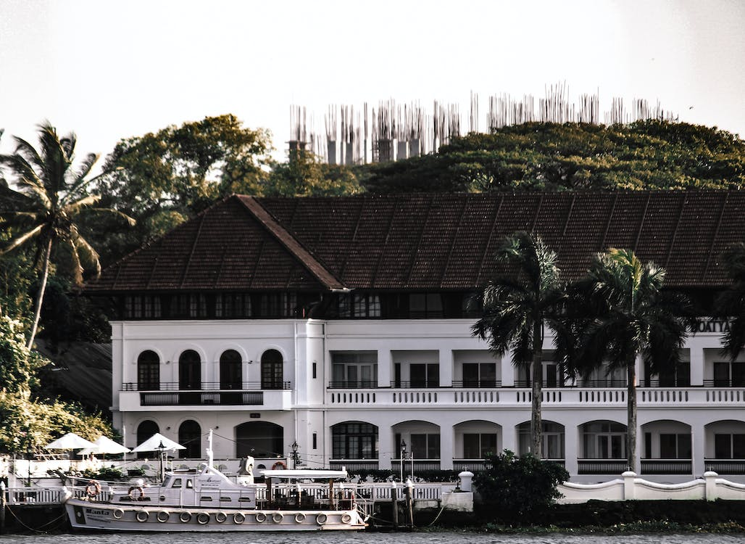After a relaxing breakfast at the hotel, the tour guide will pick you up from the hotel and take you for a guided sightseeing tour of Cochin. Tour includes the following places of interest:

Dutch Palace (Mattancherry Palace): The Portuguese constructed The Mattancherry Palace in 1557, and presented to the Maharaja of Cochin, Veera Kerala Varma (1537-61) as sign of goodwill. After 1663, the Dutch carried out some constructions and renovations in the palace, and from that day it was widely called as the ‘Dutch Palace’. The most significant thing about this palace is the amazing paintings in the bedrooms and other rooms. The paintings portray scenes from the Ramayana, Mahabharata and Puranic legends connected with Shiva, Vishnu, Krishna, Kumara and Durga. These paintings are certainly the most extensive and attractive paintings to be seen anywhere in India.

The Jewish Synagogue: The Jewish Synagogue is located near the Dutch Palace. This synagogue was constructed in 1568 and was brilliantly decorated by Chinese tiles and Belgian chandeliers. The Synagogue has a giant scroll of the Old Testament.

Cochin Harbor: The very popular tourist attraction in Cochin Harbor is the Chinese Fishing nets. These fishing nets are one of its kind and are found only in India. The fishing nets were popularized in Cochin Harbor by the traders from the court of the Chinese ruler Kublai Khan.

St Francis Church: St. Francis church was constructed by the Europeans in 1503. St. Francis Church is the oldest European church in India. The Portuguese trader, Vasco da Gama died in Kochi, during his third visit to Kerala. Initially, his body was buried in this church, but after a few years his remains were moved to Portugal. In spite of all this the place where he was buried has been marked out inside the church.

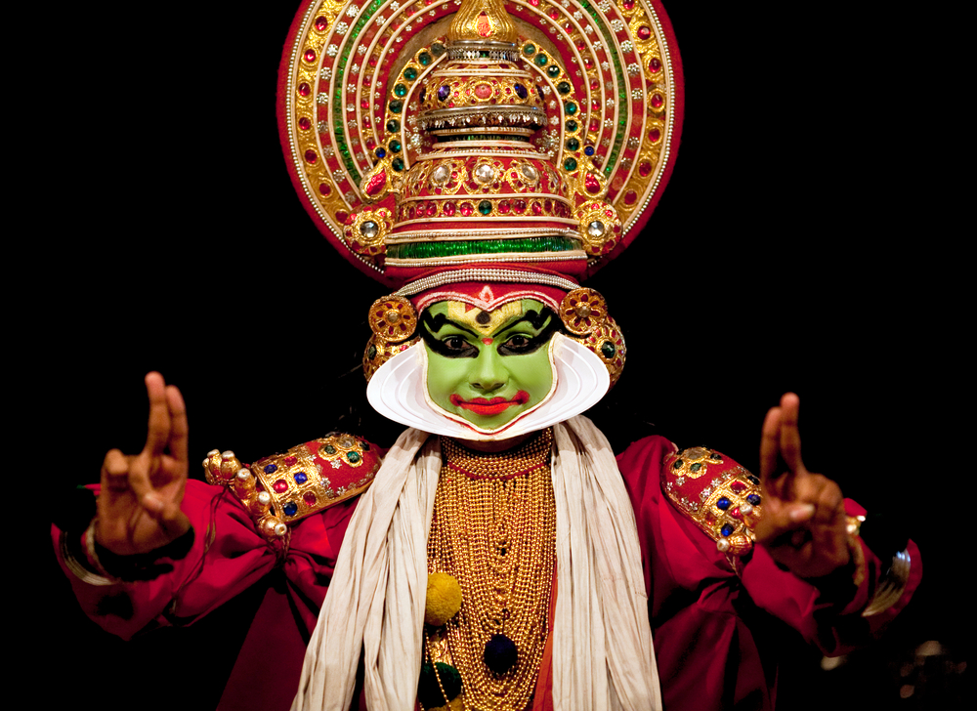
Fort Kochi Beach: Fort Kochi beach is an ideal location to saunter in a peaceful and relaxing way. This beach happens to be one of the favourite tourist spots in Kerala. The view of the sunset with the Chinese fishing net and the sailing ships in the background is a fine experience. Many European style bungalows can be seen alongside the shoreline.

Later in the evening you will be picked up by the guide and will be taken to a Kathakali Dance Performance at a local theatre. Kathakali is a classical dance form, portraying Indian epics (Ramayana and Mahabharata). The costumes of the dancers are very colourful and elaborate. Dancers with painted faces depict the various characters of the ancient epics. The Kathakali dancers portray a lot of facial expressions and articulate body movements.

Overnight at the hotel
Meals – Breakfast

Day 03 – Cochin – Periyar (150 Kms. / 04 hrs.)
After a relaxing breakfast at the hotel, you will be met by our representative and he will assist you with the check-out formalities. And then you start your drive to Periyar, the next destination on your Best of Kerala Tour.

Periyar: Periyar is one of the most popular National Parks in Southern India, but these days this is more famous for its serene feel, than for sightings of wildlife. The uniqueness of the sanctuary extends around the banks of a huge artificial lake that was created by the damming of the Periyar River a century ago. The sanctuary is known for the Tigers. It has a wide range of animals, including elephants, bison, macaque leopards, jungle cats, wild dogs, mouse deer, gaur, sambar deer, barking deer. The sanctuary treasures a wide variety of rich flora and rare fauna.

On your arrival in Periyar, check in at the Spice Village resort.
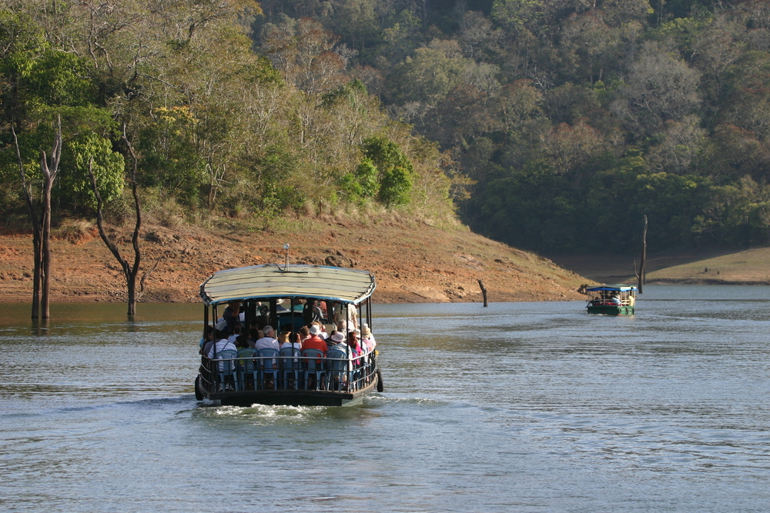
Spice Village: Spice Village is an eco-friendly traditional Keralan style resort on the outskirt of the wildlife sanctuary. Spice Village is spread over a vast area. The cottages of the resort are surrounded by a magnificent plantation which boasts hundreds of species of flowers, spices and plants. The resort also has a Resident Naturalist, who escorts you to an informative walk through the plantations.
Later, in the evening the guide will pick you up from the hotel for a guided tour to the nearby spice plantation. Cinnamom and ginger, pepper and cardamom, and various other spices grown on the Periyar hill made it nature’s taste factory in the 14th century, as Cochin became nature’s harbor, the shipping port for a spice hungry world. Later, the area came under the kingdom of Travancore, and many of its plantations, orchards and hunting lodges date from that time. The British Raj also left its mark on the Cardamom hills.
Overnight at the hotel
Meals – Breakfast

Day 04 –Periyar – Kumarakom (120 Kms. / 03 hrs.)
To experience the incredible sanctuary, early morning you will be picked up for a boat ride on the Periyar Lake. Most of the tourist activities are focused around the Lake. There are roughly 700 elephants roaming in the forest, and they are generally seen on the banks of the Periyar Lake.
Later, you start your drive to Kumarakom, the next destination on you Best Of Kerala Tour.
Kumarakom: Kumarakom is a small village on the Vembanad Lake in Kerela. This beautiful paradise stocked with mangrove forests, beryl green paddy fields and coconut groves comprises with water ways and canals adorned with while lilies. Kumarakom charms the tourist from all over the world. It offers a wide variety of flora, beautiful sightseeing, boating and fishing experiences. It is a part of Kuttanad region and the bird sanctuary spread over 14 acres is a safe home for many migratory birds. It is a fascinating sight for the visitors. The best way to watch the birds of the 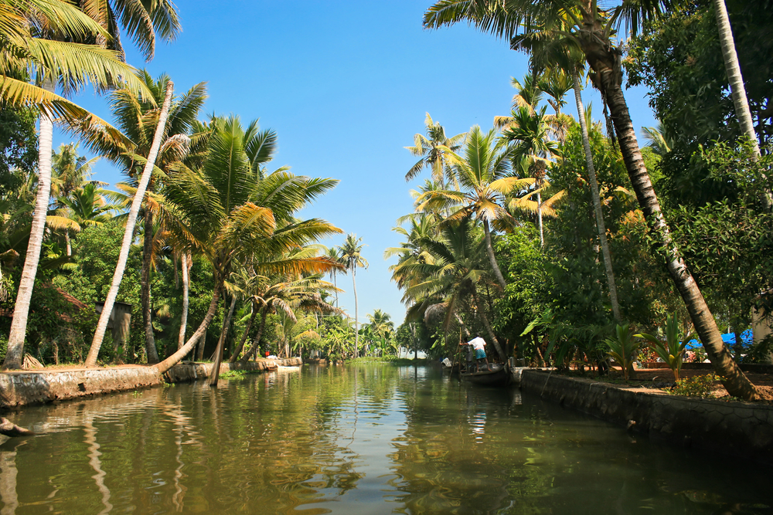Kumarakom sanctuary is a boat ride round the islands, as hundreds of swaying verdant coconut palms lining the rivers lean to brush the tops of your heads.
On your arrival in Kumarakom, check in to the Coconut Lagoon Resort, located on the edge of the Vembanad Lake.
Coconut Lagoon Resort: The Coconut Lagoon Resort is situated on the Eastern shore of Vembanad Lake. This resort is a set on an abandoned coconut plantation and has been designed and planned to give visitors an authentic sight into Kuttanad life. The resort houses individual cottages called as the Tharawads, the traditional wooden houses of Kerala. Some of these cottages are century old and some dates back to the early 1700s but some of them are constructed recently. The Heritage Mansions and the Heritage Bunglows are furnished in a way that they all retain the mystic beauty of the original family home. The resort features a private, present-day, outdoor bathroom, complete with a banana tree reaching up through the open roof. The food is served in the resorts restaurant, housed in one of the most beautiful Tharawads. The resort is well known for its superb Keralan (veg and non-Veg) cuisine. It also has a pool area which is overlooked by an attractive teak wood bar and plenty of hammocks all over the property for the afternoon nap.
The day is free for you. You can relax and enjoy the facilities of the resort.
Overnight at the hotel
Meals – Breakfast

Day 05–Kumarakom- Houseboat
After a relaxing breakfast at the resort, board on your private Houseboat for an overnight stay.
Houseboat - One of the high points of your Best Of Kerala tour, will be the night spent on board the Houseboat. These rice barges or “Kettuvallams” sail alongside the shallow palm-edged lakes and narrow canals. The House Boat takes
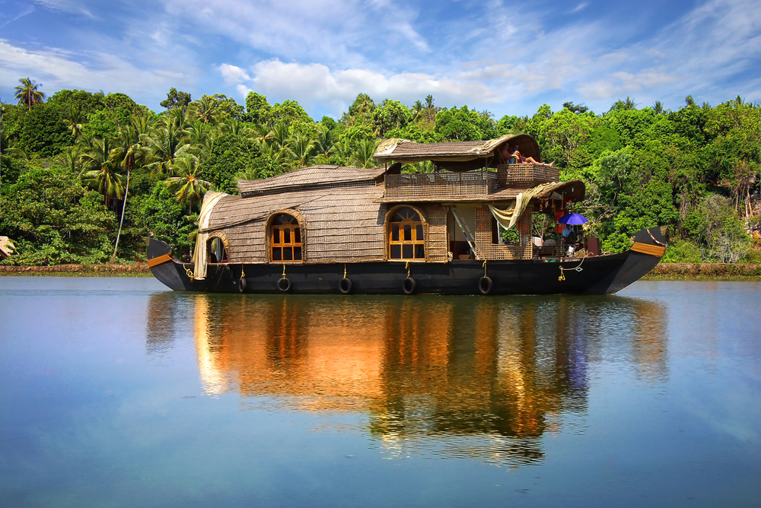
you through the villages constructed on narrow spits of land, where you can stop at the local markets, or to see the wonder of the craftsmen engaged in centuries-old boat-making tradition. These Houseboats offer one or two small cabins with a tiny sitting area and a crew of 2 staff and a chef. The Houseboats serve authentic Keralan cuisine. The overnight stay on the Houseboat is an extraordinary experience.
Overnight at the Houseboat
Meals – Breakfast, Lunch & Dinner

Day 06–Houseboat - Mararikulam (30 Kms /45minutes)
After a relaxing breakfast, and a bit of cruising on the lake, disembark your Houseboat in either Alleppey or Kumarakom, and then drive to Mararikulam
Mararikulam: Mararikulam is a village in India, in the district of Alappuzha, Kerala state. Marari Beach in the Alappuzha district is a go-to destination for beach bums who want to laze around in a peaceful, serene and pristine environment. The name 'Marari' is short for Mararikulam, which is a beautiful fishing village lying along this coast.
Marari Beach Resort: Marari Beach is part of the CGH Group and provides an authentic experience of Kerala traditional and recreation. The small resort is set in the coconut grove at the sandy Marari Beach surrounded by flowering plants and herb gardens. There’s plenty to experience at the Marari Beach Resort. The locals often host festivals showcasing their traditions and culture. At the Ayurveda Centre, guests can experience an authentic Kerala massage from trained therapists. Also available are yoga classes from a master yoga teacher. Furthermore, visitors have the option of attending a cooking class at the Farm Kitchen.
On arrival, transfer to the resort
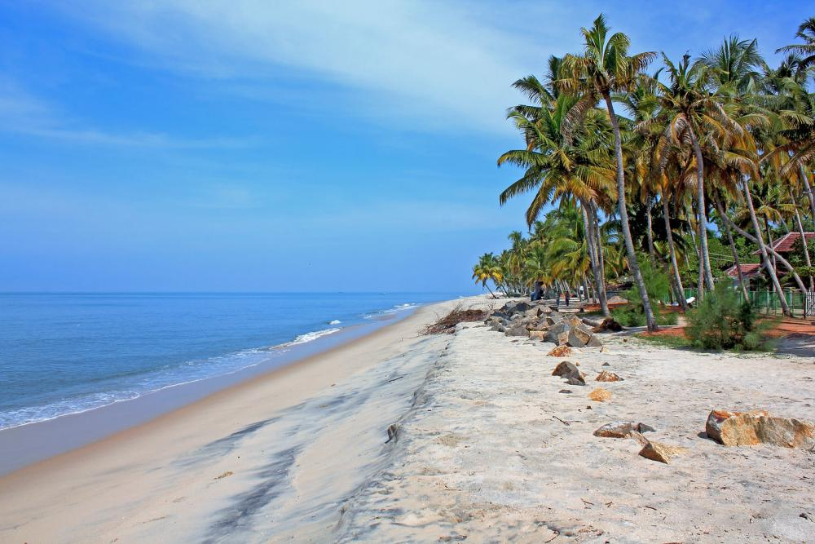

Overnight at the hotel
Meals – Breakfast
Day 07–Mararikulam
Day free for your own activities
Overnight at the hotel
Meals – Breakfast
Day 08–Mararikulam - Cochin (75 Kms. /02 hrs.)
Cochin – Departure
Intime, transfer to the Cochin international airport to board the flight for onward destination
Meals – Breakfast

***End of Tour***

