Southern Africa Touring Services
Phone: (263-4)776840 /55 Fax: (263-4)776801
Email: sats@sats.co.zw Web: www.victoriafallssats.com
Physical Address: SATS House, 27 Wembley Crescent, Eastlea, Harare, Zimbabwe
TOUR REF | 3D2N LVI & VFA
TOUR CONSULTANT
EMERGENCY CONTACTS

DAY 01 | NBOLVI KQ782 0730/0945  Arrive at Livingstone airport, meet & assist with immigration procedures  Transfer to hotel  Lunch at hotel  Guided tour of the Falls, Zambia side  Dinner at hotel  Hotel: Avani Victoria Falls Resort-4* avanihotels.com/victoria-falls  Royal Livingstone Hotel-5* royal-livingstone.anantara.com  Victoria Falls is one of the Seven Natural Wonders & largest waterfall in the World. Victoria Falls is located on the border between Zambia and Zimbabwe. The name Victoria Falls was given to the falls by the Scottish explorer Dr. David Livingstone. He named the falls after the reigning queen at the time. The locals called the falls Mosi-Oa-Tunya meaning “smoke that thunders.” You will find the famous statue of Dr David Livingstone overlooking the Falls, a set of stairs going down to a view point called the “Chain Walk”– where you will be able to look into the Devils Cataract, where the river has cut almost 10 meters lower than along the rest of the Falls, the designated path along the way takes you to the various 16 view points along the edge, offering views of the main falls, the Rain Forest as it is known, a small area of riverine jungle supported by the spray of the Falls and moist conditions surrounds the pathway.  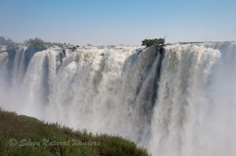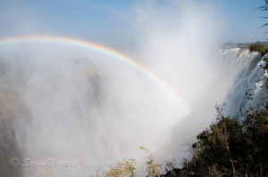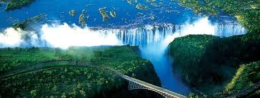
DAY 02 | LVI-VFA  After breakfast, transfer to pass through immigration into Victoria Falls, Zimbabwe  Guided tour of the Falls, Zimbabwe side  Lunch at the Look-Out Cafe  Sunset cruise on the mighty Zambezi river inclusive of drinks & snacks  Dinner at the Boma restaurant inclusive of African folklore  Hotel: Kingdom Hotel -4* www.legacyhotels.co.za/en/hotels/thekingdom/  Victoria Falls Hotel-5* www.victoriafallshotel.com  The Zambezi river, Africa’s 4th longest river & home to many hippo, crocodile, & other animal species. A Sunset Cruise on the Mighty Zambezi River above Victoria Falls gives you unforgettable experiences not to be missed, approx. 2hr30mins. Relax with a sundowner and snacks as you gaze out onto the banks of the river for approx. 2hrs. You'll be sure to spot wildlife animals as they come down to the river for a drink after a hot day in the Zambezi National Park (Zimbabwe) and the Mosi-Oa-Tunya National Park (Zambia). Sightings of elephant, giraffe, hippos, crocodiles and other resident game are common. Birdlife is superb and the Fish eagles will usually fill the scene with their calls.  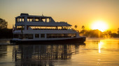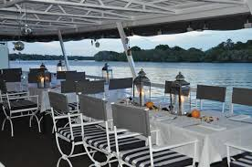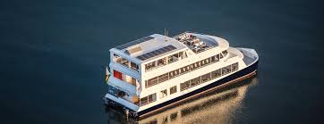  The Boma Place of Eating. The Boma provides a unique cultural experience that bombards the senses with the tastes, sights, sounds & smells of Africa – together with the warmth and hospitality of Victoria Falls, Zimbabwe and its people. Guests are welcomed with a traditional greeting in the local languages, Shona and Ndebele. The guests are then dressed in ‘chitenges’ (traditional robes) and prepared to enter the main enclosure. They are invited to take part in a hand washing ceremony before sampling traditional beer and snacks, as a prelude to dinner.  A feast of nightly entertainment incorporates Amakwezi traditional dancers, a local story teller and a witchdoctor. After dinner, guests are invited to join in the drumming extravaganza from 21h00. This is the highlight of the evening and all are invited to participate in the drumming and dancing show with our renowned drummers.  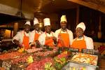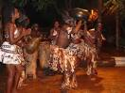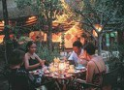
DAY 03 | VFA – LVINBO KQ783 1815/2220  After breakfast, transfer to pass through immigration to Livingstone  Tour of the David Livingstone Museum & the craft market  Lunch at Ocean Basket  Transfer to Livingstone airport for departure flight.  The David Livingstone Museum houses the most comprehensive memorabilia of the explorer and Missionary, Dr. David Livingstone. A guided tour offers an interesting sight into the life and work of one of the world’s great explorers. There are also very interesting displays on the Stone Age people who first lived in this area and an African cultural section that includes traditional living, medicines and witchcraft.  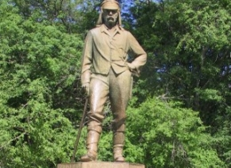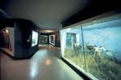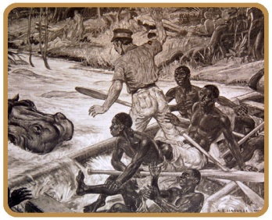
Inclusions:
>Meals：As per itinerary
> Accommodation : In standard rooms as per itinerary
>Tours：As per itinerary. At leisure time clients can choose optional activities
>Guides: Professional Local English Speaking
>Entrance fees：Included for tours in the Itinerary
>Hotels：As per Itinerary
>Porterage & Bottled Water -1 bottle per person per day

Exclusions:-
>Visa –Zambia double entry us$100p/p, Zimbabwe single entry us$40p/p
>Drinks with meals
>Gratuities. Gratuity is expected for good service in restaurants.(please make allowance in your budget)
>Tips for Driver/Guide (please make allowance in your budget)
>All expenses of personal nature i.e. laundry & phone calls
>International, regional and domestic flights and airport taxes
>Travel Insurance
>Agents Commission
>All optional excursions and activities
>Any item not specifically listed in the itinerary above.

