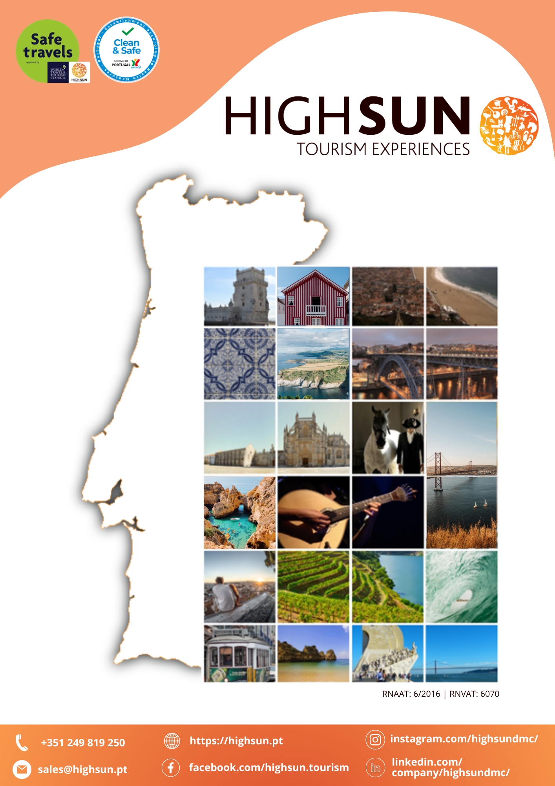

**Proposal**

**TASTE OF LISBON**

This suggested short-stay itinerary is the perfect way to experience the charm and vibrancy of Lisbon and its surroundings.

Over four nights, discover a city that blends centuries of history with a dynamic, contemporary spirit. Wander through the cobbled alleys of Alfama, admire the elegance of Belém, and enjoy sweeping views from Lisbon’s many hilltop “miradouros”. With a balanced mix of cultural experiences, free time, and the insight of local guides, this itinerary offers a rich and rewarding escape—ideal for those looking to immerse themselves in the essence of Portugal’s capital city and nearby coastal gems like Sintra or Cascais.

**Day 1 – Lisbon**

Arrival at Lisbon Airport and private transfer to chosen hotel in Lisbon.

Rest of the day at leisure.

Overnight.

**Day 2 – Lisbon**

Breakfast at the hotel.

In the morning, discover the fascinating world of Portuguese tiles in a hands-on, creative workshop. Guided by a professional artist, you'll explore the history and contemporary use of azulejos while painting two of your own. Whether you're an art enthusiast, a curious traveler, or simply looking for a unique cultural experience, this workshop is a perfect blend of creativity and tradition.

You'll get to paint two tiles, which will then be kiln-fired to preserve your artwork — a beautiful and personal souvenir from Portugal. Please note that the tiles need to be fired after painting, so they won’t be ready to take home on the same day.

Afternoon free at leisure.

Return to the hotel and overnight.

**Day 3 – Lisbon**

Breakfast at the hotel.

Today, discover Lisbon from a new perspective on this riverside e-bike tour to Belém, following the path of Portugal’s great navigators. Starting at the iconic Commerce Square, you’ll cycle past architectural gems like Cais das Colunas and Ribeira das Naus, glide under the 25th of April Bridge, and climb to the Christ the King statue for unforgettable panoramic views.

Along the way, explore the creative vibe of the Dock Area, pass by the MAAT museum, and dive into Portugal’s maritime legacy at the Monument of Discoveries and the Jerónimos Monastery. Your journey ends at the stunning Belém Tower, a true symbol of Lisbon’s golden age.

Led by a passionate local storyteller, this tour includes a brief e-bike lesson, a delicious Portuguese custard tart, and full insurance coverage. Perfect for history lovers, design enthusiasts, or couples looking for a unique experience — this is a fun, cultural adventure along Lisbon’s most beautiful riverside path.

Afternoon free at leisure.

Return to the hotel and overnight.

**Day 4 – Lisbon**

Breakfast at the hotel.

**Option A:** Follow the iconic route of **Lisbon’s Tram 28** in a 1.5-hour eco-friendly **Tuk-Tuk tour**. Discover historic squares, charming neighborhoods, and must-see landmarks like Estrela Basilica, Belém, and Jerónimos Monastery.

Enjoy stunning views from Graça and local stories from your guide. A relaxed, sustainable experience perfect for couples, families, and small groups.

**Option B:** Explore **Sintra’s magic in a Full Day Minubus Tour** with visits to Pena Palace and its lush park (tickets included). Enjoy local pastries in Sintra village, and take in the stunning views from Cabo da Roca, Europe’s westernmost point. Continue along the Atlantic coast, stopping at Guincho Beach and Cascais, with free time to enjoy the bay or beach. Return via Estoril gardens and casino.

**Option C:** Enjoy your **free day exploring Lisbon** at your own pace. Whether it’s strolling through picturesque neighborhoods, relaxing at a sunny terrace, or discovering hidden local gems, the city is yours to enjoy.

**Day 5 – Lisbon**

Breakfast at the hotel and check-out. Enjoy a leisurely morning to do some last-minute shopping or to explore Lisbon’s charming streets, historic monuments, and cozy cafés one last time. At the scheduled time, a private transfer will take you to Lisbon Airport for boarding formalities and your departure on the selected flight. Say farewell to Portugal—with the feeling that you’ll be back again soon!

**Included**

* 4 nights accommodation at chosen hotel in double occupancy with breakfast;
* Private arrival and departure transfers;
* Tile Paiting Workshop;
* Follow the River to Belém E-Bike Tour.

**Not Included**

* Suggestions mentioned in the itinerary;
* City taxes;
* Flights and visas;
* Personal expenses;
* **Any items or services not explicitly mentioned as included.**

**BUDGET**

|  |  |  |
| --- | --- | --- |
| Hotel | Season | |
| **01.05.2025 - 31.10.2025** | **01.11.2025 – 31.03.2026** |
| Turim Luxe Hotel  3* | 420€ | 408€ |
| Turim Lisboa Hotel  4* | 479€ | 467€ |
| Turim Boulevard Hotel  5* | 785€ | 773€ |

**Price per person / in euros (€) / NET / With VAT**

***Note:*** *Based on a minimum of 2 people in a double room. If the hotel listed in the selected category is unavailable, an equivalent or superior alternative will be provided.*

**OPTIONALS**

|  |  |
| --- | --- |
| Follow The Tram 28 - 1,5 Hour TukTuk Tour | 139€  Per TukTuk |
| Sintra, Cascais & Estoril with Pena Palace - Full Day Van Tours | **95€**  **Per Person** |

**GENERAL CONDITIONS**

* This is a proposal only; no reservations have been made. Upon booking, the availability of all proposed services must be confirmed. If any service is unavailable, a suitable alternative will be offered for approval.
* HighSun reserves the right to modify the program or itinerary (including hotels, activities, restaurants, services, etc.) without entitlement to compensation, due to external factors such as bad weather, venue maintenance/closures, scheduling conflicts, etc. In such cases, HighSun will, where possible, offer a similar alternative experience.