5 NIGHT / 6 DAYS
ISTANBUL – CAPPADOCIA

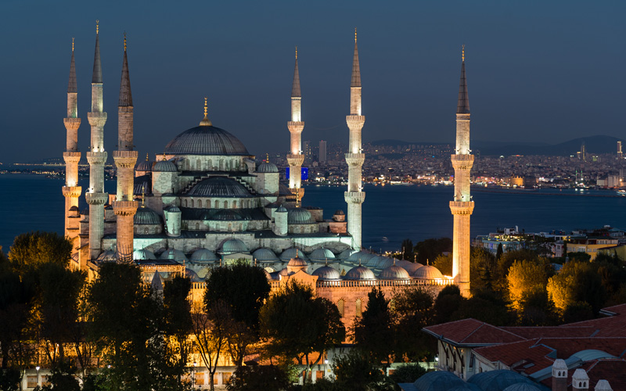

DAY 1 Arrival to Istanbul
Arrival to Istanbul Airport. After immigration and customs formalities, board your vehicle for transfer to the hotel. Overnight in Istanbul. ( - )
optional : Dinner cruise on the bosphorus ( includes un-limited local drinks - belly dance show - Turkish folk dance shows and DJ performance ) per person :75 euro

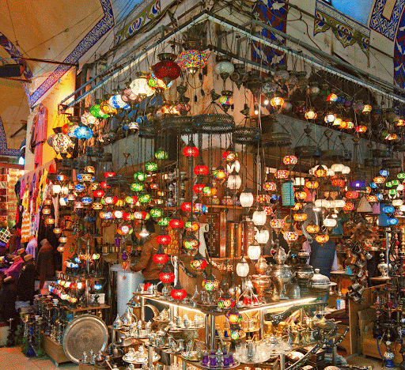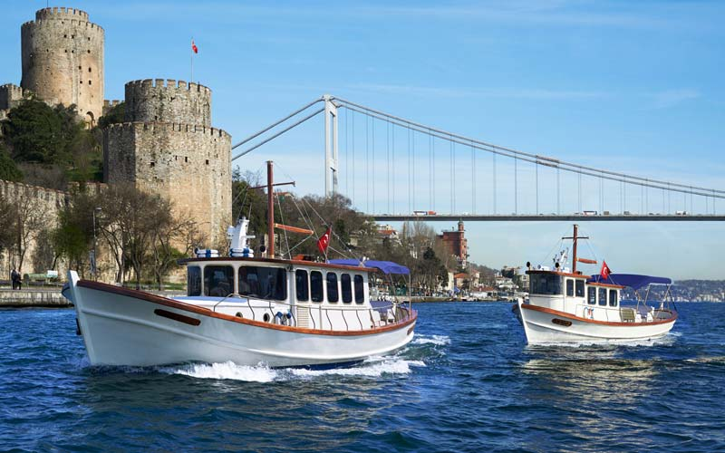

DAY 2 Istanbul explore the city
Today after breakfast; We begin our tour of the Sultanahmet district, the heart of old Istanbul, at Saint Sophia. Built by Emperor Justinian in the 6th century AD, this church is one of the marvels of world architecture. Its massive dome dominates the skyline of old Istanbul. It is famed for its mosaics, including glittering portraits of emperors and empresses. Next we visit the Blue Mosque, which owes its name to the exquisite tiles adorning its interior. Dating from the 17th century, it is the only imperial mosque with six minarets. The Hippodrome, the stadium of ancient Byzantium, held 100,000 spectators and featured objects from all corners of the empire. Of these, an Egyptian obelisk and a bronze sculpture of three entwined serpents from Delphi survive.
Afternoon; we begin our tour at Topkapi Palace, which, from the 15th to the 19th century, was the principle residence of the Ottoman Sultans. We will visit the fabolous Imperial Treasury and the Baghdad Kiosk. Topkapı Palace is now a museum and has unrivalled collections of jewelry, including the Spoonmaker’s Diamond, the 3rd largest in the world, Ottoman court costumes and ceramics, notably one of the world’s finest collection of early Chinese ceramics, much of it gifts from other rulers. Interestingly, some of the ceramics have a special glaze that was said to change color in the presence of poison. We also visit the Imperial Armory, displaying centuries of Ottoman weaponry. But perhaps the loveliest features of Topkapı Palace are its courtyards with their ancient trees, and it is easy to imagine the sultan strolling here far from the cares of state and empire.
The last stop, Grand Bazaar, was the commercial heart of the old city and its 4,000 shops are full of treasures – including carpets and kilims, silks, jewelry, ceramics, icons, and leather goods. Wandering through the Grand Bazaar, indulge in some shopping, Ottoman style. O/N at the hotel.. ( B,L )
DAY 3 Istanbul / Full day bosphorus cruise & two continets tour.
After breakfast and start half day spice Market & Bosphorus cruise.tour & afternoon cross the bosphorus bridge & visit Camlica Hill & Beylerbeyi Palace ( old ottoman summer palace ) O/N at the hotel. (B,L )

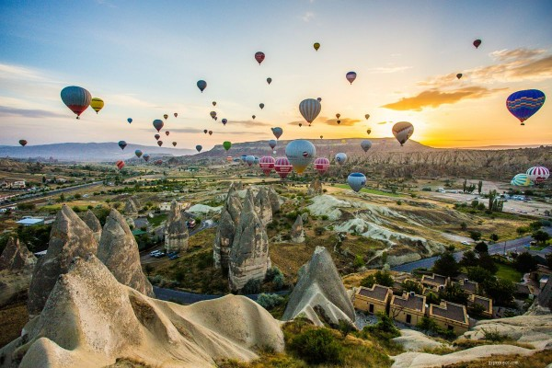

DAY 4 Istanbul - Cappadocia ( by flight )
Breakfast at the hotel & transfer to airport & flight to Cappadocia Arrival & Transfer to your hotel. O/N. (B,D )
DAY 5 Exploring Cappadocia
OPTIONAL : Early morning available to make hot air balloon riding ( pick up around 04.00 am belongs to sun rising time !!!! ).( Per Person 300 euro )
Breakfast at the hotel & depart your hotel for a Full Day tour in Cappadocia. Visit Goreme Open Air Museum in Goreme Valley to see the early Christian churches decorated with unique frescos depicting various scenes from the Bible. Visit Pasa baglari (Monk’s Valley) to see the world famous fairy chimneys which have unique shape. Later you will visit Avanos Town, the very well known pottery
and craft center since Hittite times. Enjoy hand made ceramics, fashion design jewellery. End of the tour transfer back to your hotel & O/N.( B,L,D )
Average Pick-up time: 09.30 - 10:00 Approximate Tour Duration: 07 hrs

DAY 6 Cappadocia - Istanbul (by flight )
After breakfast transfer to airport & flight to Istanbul & take a connection flight to your country. ( B )
B : BREAKFAST / L : lunch / D: dinner

all drinks are extra
INCLUDES :
AIRPORT TRANSFER PRIVATE & TOURS ARE ON REGULAR BASIS
3 night accommodation in Istanbul BB
2 night accommodation in Cappadocia H/B
2 Full Day. Istanbul City Tour
1 Full Day Cappadocia City Tour
All airport transfers ( Istanbul & Cappadocia )
Entrance fees mentioned on the program
Professional English Speaking guide during sightseeing
Excludes :
Anything not mentioned on the itinerary and inclusions
Optional tours
Tips
Personal expenses
Drinks at the meals
Optional Tours: ( Balloon riding & bosphorus cruise dinner )
Domestic Flight tickets are excluded ( airfares are changeable depends on dates APRX. per person r/t 250- 300 euro )

HOTELS :
ISTANBUL GOLDEN AGE TAKSIM 4* B&B
CAPPADOCIA PERISSIA HOTEL 4*+ H/B
HOTELS ARE SUBJECT TO AVAILIBILITY

PACKAGE RATE VALID BETWEEN 20/06/2026 - 28/02/2027
PP IN DBL / TWIN ROOM : 850 EURO
SINGLE SUPPL. : 300 EURO
PP IN TRPL ROOM : 825 EURO

PLEASE AS SUPPLEMENT FOR PRIVATE SERVICE !!!

