7 NIGHTS / 8 DAYS
ISTANBUL – CAPPADOCIA– KUSADASI - PAMUKKALE

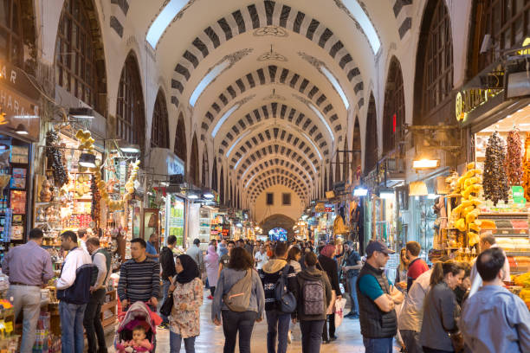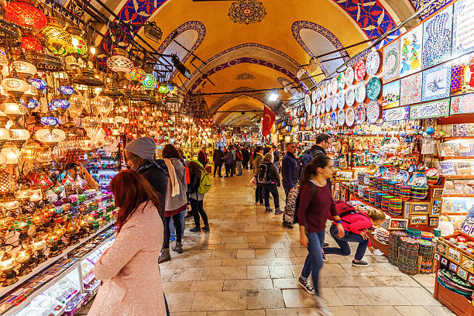

DAY 1 Arrival to Istanbul
Arrival to Istanbul Airport. After immigration and customs formalities, board your vehicle for transfer to the hotel. O/N . ( - )
DAY 2 Istanbul explore the city
Today after breakfast; We begin our tour of the Sultanahmet district, the heart of old Istanbul, at Saint Sophia. Built by Emperor Justinian in the 6th century AD, this church is one of the marvels of world architecture. Its massive dome dominates the skyline of old Istanbul. It is famed for its mosaics, including glittering portraits of emperors and empresses. Next we visit the Blue Mosque, which owes its name to the exquisite tiles adorning its interior. Dating from the 17th century, it is the only imperial mosque with six minarets. The Hippodrome, the stadium of ancient Byzantium, held 100,000 spectators and featured objects from all corners of the empire. Of these, an Egyptian obelisk and a bronze sculpture of three entwined serpents from Delphi survive.
Lunch at Restaurant.
Afternoon; we begin our tour at Topkapi Palace, which, from the 15th to the 19th century, was the principle residence of the Ottoman Sultans. We will visit the faboulous Imperial Treasury and the Baghdad Kiosk. Topkapı Palace is now a museum and has unrivalled collections of jewelry, including the Spoonmaker’s Diamond, the 3rd largest in the world, Ottoman court costumes and ceramics, notably one of the world’s finest collection of early Chinese ceramics, much of it gifts from other rulers. Interestingly, some of the ceramics have a special glaze that was said to change color in the presence of poison. We also visit the Imperial Armory, displaying centuries of Ottoman weaponry. But perhaps the loveliest features of Topkapı Palace are its courtyards with their ancient trees, and it is easy to imagine the sultan strolling here far from the cares of state and empire.
The last stop, Grand Bazaar, was the commercial heart of the old city and its 4,000 shops are full of treasures – including carpets and kilims, silks, jewelry, ceramics, icons, and leather goods. Wandering through the Grand Bazaar, indulge in some shopping, Ottoman style. Return back to your hotel.. O/N.( B,L )

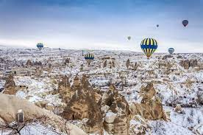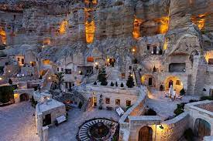

Day 3 Istanbul & Cappadocia ( by flight )
After breakfast check out from your hotel.& transfer to airport Flight to Kayseri or Nevsehir airport. Transfer to Cappadocia cnetre around 80 kms and Lunch at Local cave restaurant. Afternoon start sightseeing Visit to Kaymakli undergraound city & Pigeon valley lastly visit to jewellery shop . transfer to your hotel Dinner at the hotel. Overnight in Cappadocia. ( B,L,D )
Day 4 Exploring Cappadocia
OPTIONAL : Early morning available to make hot air balloon riding. ( per person 300 EURO )
After breakfast tour start with Devrent valley; walking in Pasabag near Zelve ; "fairy chimneys" where the voice of wind mixes with the "songs of fairies". Lunch in Avanos, centre of terra cotta work of art since 3000 BC. and a demonstration in a traditional pottery workshop. Afternoon, visit the famous Goreme Open Air Museum and see the best examples of Byzantine art in Cappadocia in rock-cut churches with frescoes and paintings (10th to 13th century). Continue to the Uchisar Rock-Castle to have a panoramic view of the valleys of Cappadocia. (B,L,D )
DAY 5 Cappadocia Tour & Izmir Airport / Kusadasi ( by flight )
After breakfast, c/out & transfer to airport & flight to Izmir airport; After landing transfer to Kusadasi transfer to Hotel. Dinner &O/N at the hotel. ( B,D )

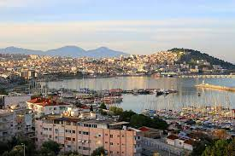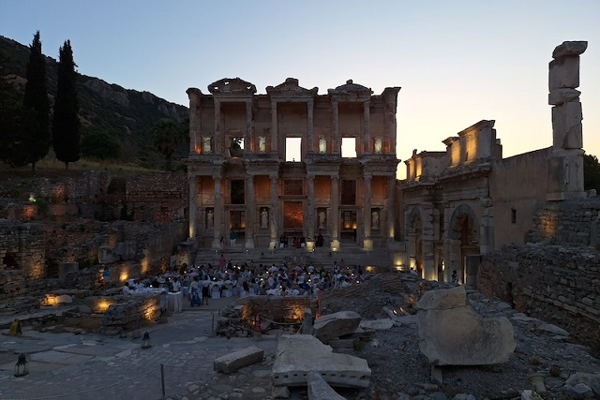

DAY 5 Ephesus tour
After breakfast start sightseeing; you will pass through the verdant countryside before arriving at Ephesus. Our first stop is the Virgin Mary s House you will drive nearly for 25 minutes. According to Predominant Christian tradition, Mary was brought to Ephesus by the Apostle John after the Resurrection of Christ and lived out her days there. This is based mainly on the traditional belief that John came to Ephesus combined with the biblical statement that Jesus Consigned her to John's care. Ephesus tour is starting with your local Ephesus guide; walking tour will take you through one of the most magnificent excavations in the world. See the Odeon, The Fountain of Trajan, the five terraces of apartment houses, the stream baths of Scholastic, the temple of Hadrian and impressive library of Ephesus. The library is adorned with columns and statues. The Grand Theatre, where Saint Paul preached, is the largest theatre is antiquity with capacity of 24.000 seats. You will return to the bus through the Arcadian Way, where Mark Anthony and Cleopatra once rode in procession. The visit of Ephesus Open Air Museum takes nearly 2 hours. After the Lunch Break, The next stop on your tour is the Temple of Artemis (Diana), built in a honour of the Greek Goddess of hunting, wild nature and fertility, Deemed as one of the Seven wonders of the ancient world .The temple of Artemis used to be the largest marble temple in the ancient Greek world since it was four times as the big as the Parthenon in Athens, Greece. The temple served as both a marketplace and religious’ institution. Offerings by thousands of pilgrims each year enable the temple to grow so wealthy that it became the world`s first bank. Today, little remains of the magnificent structure. Your guide will describe its importance, its wealth and tension that existed between the Romans and Christians that settled in the area over the centuries. End of the tour, transfer back to your hotel.Dinner & Overnight in Kusadasi.(B,L,D )

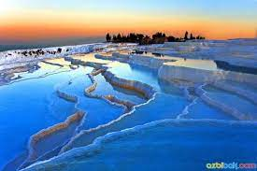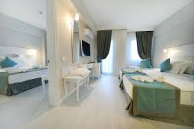

Day 7 Kusadasi / Pamukkale
After breakfast; C/out fro the hotel & We Leaving the colourful town of behind you will pass through the verdant countryside. We will drive for 3 hours for Pamukkale (Hierapolis) to east of Kusadasi to Pamukkale, On the half way, have break for the needs.You will arrive at North Gate of Pamukkale (Hierapolis). You will see the Necropolis (cemetery) of Hierapolis which is one of the biggest ancient cemeteries in Anatolia with 1.200 graves, Roman Bath, Domitian Gate, and the Main Street, Byzantium Gate. Then, you walk to the natural warm water terraces which were formed by running warm water that contains calcium. The temperature of the water is about 35. You can see the gleaming white travertine terraces of Pamukkale, located next to the ruins of Hierapolis. The extraordinary effect is created when water from the hot springs loses carbon dioxide as it flows down the slopes, leaving deposits of limestone. The layers of white calcium carbonate, built up in steps on the plateau, gave the site the name Pamukkale (cotton castle).After the open buffed lunch Swimming in hot red thermal pools in the hotel. Then If you like to swim in the Ancient Pool which is also called Cleopatra s Pool they charge extra entrance fee. The Cleopatra Pool is warmed by hot springs and littered with underwater fragments of ancient marble columns. Possibly associated with the Temple of Apollo, the pool provides today's visitors a rare opportunity to swim with antiquities! During the Roman period, columned porticoes surrounded the pool; earthquakes toppled them into the water where they lie today. Afterwards, you drive to your hotel in Pamukkale. Dinner & O/N ( B,L,D )
Day 8 Pamukkale / Istanbul / ...........
Transfer to airport & flight to Istanbul & take a connection flight back to your Country. ( B )
INCLUDES :
All transfer Private & Sightseeing on Regualar. basis.
2 night accommodation in Istanbul B&B
2 night accommodation in Cappadocia H/B
2 night accommodation in Kusadasi H/B
1 night accommodation in Pamukkale HB
MEALS :
7 Open Buffet Breakfast
( 2 ISTANBUL - 2 CAPPADOCIA - 2 KUSADASI - 1 PAMUKKALE )
PLEASE NOTE THAT; All Drinks are extra at all meals ( lunch & dinner )
Full Day Istanbul Tour including lunch
Full Day Cappadocia Tour including lunch
Full Day Ephesus Tour including lunch
Full Day Pamukkale Tour including lunch
Entrance fees mentioned on the program
English Speaking Guide during sightseeing
Excludes; Domestic Flight tickets are excluded ( airfares are changeable depends on dates aprx. per person 300 - 450 eur ) ( WE need to use 3 domestic flight )
* ISTANBUL - CAPPADOCIA ( prefer morning flight )
* CAPPADOCIA - IZMIR ( prefer morning flight )
* DENIZLI - ISTANBUL ( prefer morning flight )
Optional tours excluded ( BALOON RIDING ) & Any other request
HOTELS :
Istanbul;
Golden Age Hotel Taksim 4* B&B ( standart room )
Cappadocia;
Dilek Kaya Hotel S' Class Boutique Hotel H/B ( cave room )
Kusadasi;
Proxima Hotel 4* H/B ( standart room )
Pamukkale ;

Pam Thermal Hotel & spa. 5* H/B ( standart room )
( hotels are subject to availibility )

PACKAGE RATES ( BETWEEN 20/06/2026 - 28/02/2027 )

PER PERSON IN DBL ROOM : 1.400 EUR
SINGLE SUPPLEMENT : 480 EUR
THIRD BED : 1.300 EUR

