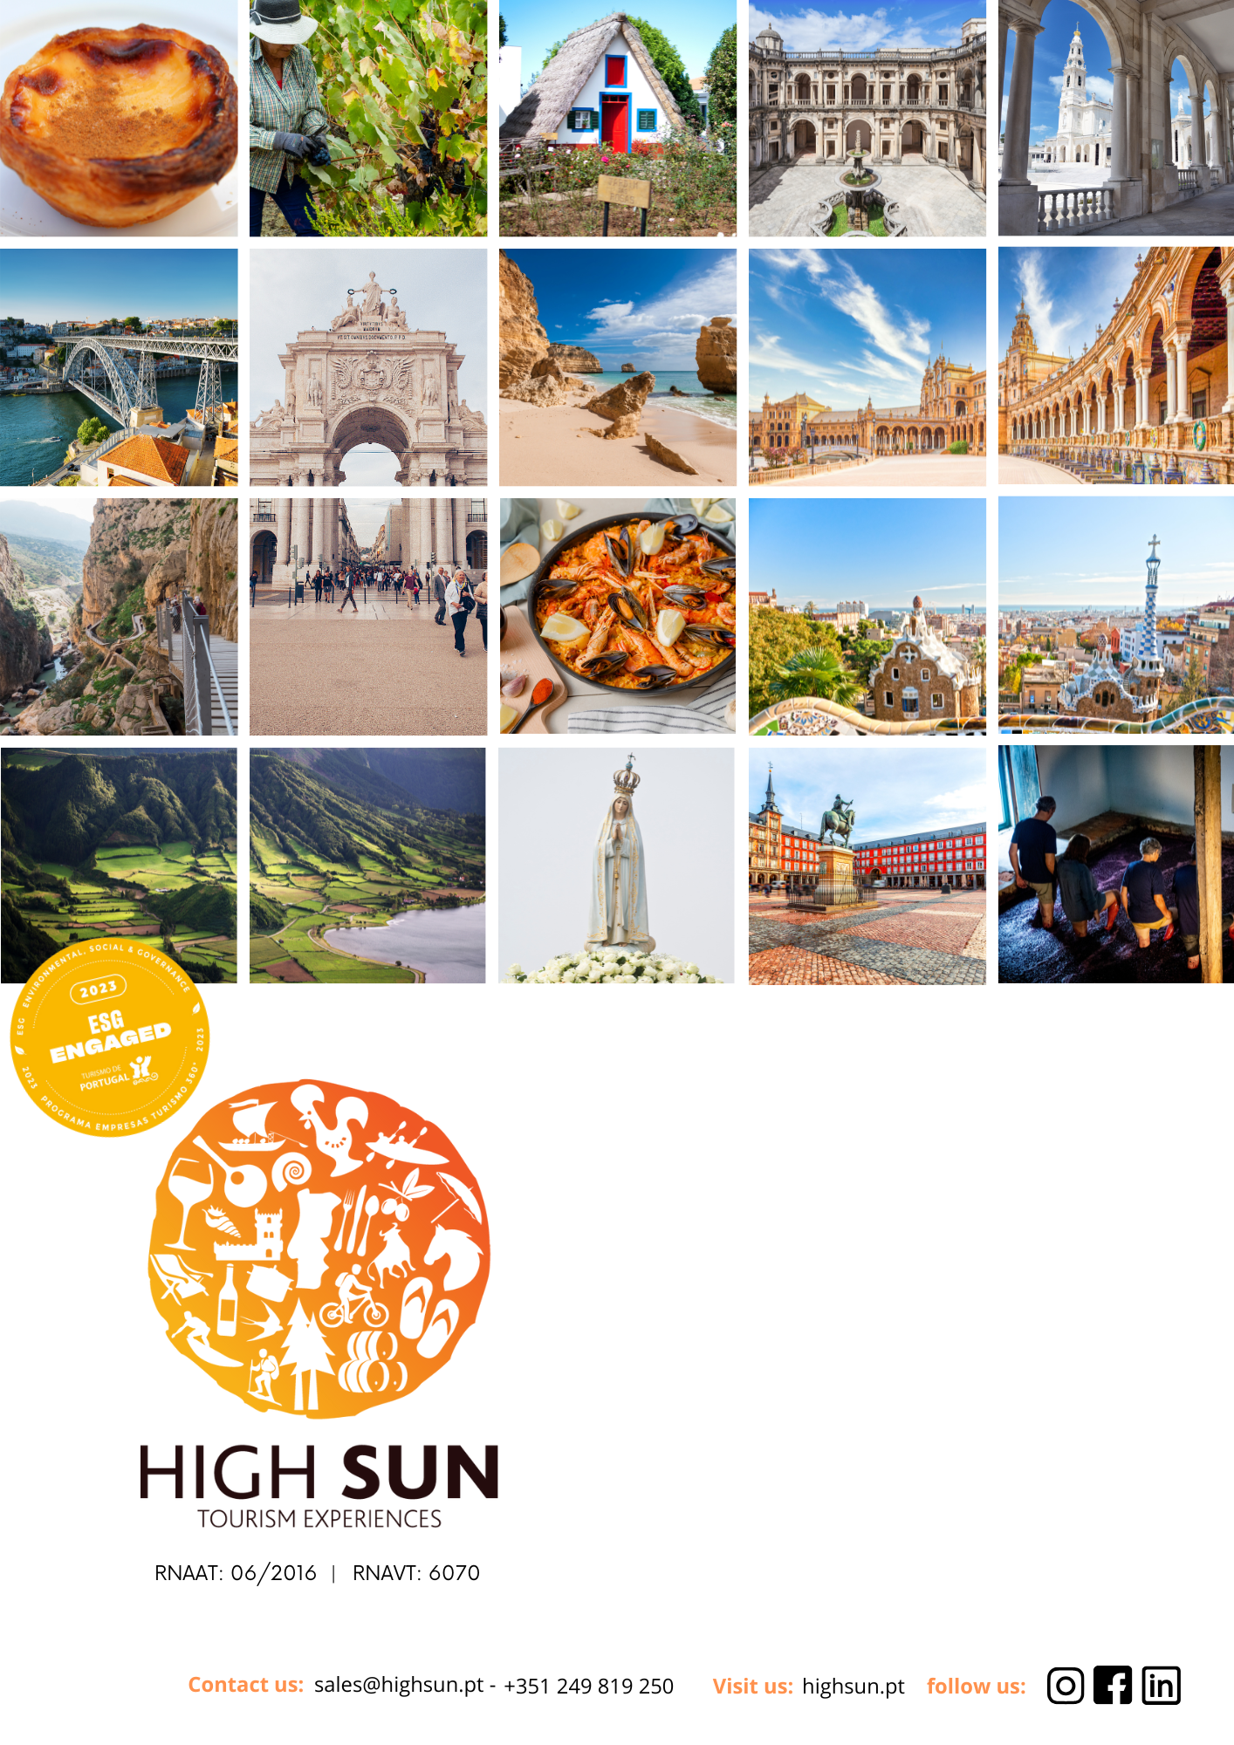
MADEIRA IN SUMMER
CONTACT US: sales@highsun.pt - (+351) 249 819 250 - VISIT US: https://highsun.pt/en/ - FOLLOW US: Instagram | Facebook | Linkedin

The Editory Garden Carmo Funchal
Accommodation
4 nights / 5 days
Located in the historic centre of Funchal, The Editory Garden Carmo Funchal enjoys a prime location for exploring the city on foot. Inspired by Madeira's natural beauty, the hotel combines comfort, simplicity and a peaceful atmosphere, making it an excellent base from which to discover the island.
Just a short walk away are the Old Town, the Farmers' Market, the marina, restaurants, shops and many of Funchal's main attractions.
Highlights
• Central location;
• Modern and comfortable rooms;
• Outdoor swimming pool;
• Restaurant;
• Bar;
• Fitness room;
• Complimentary Wi-Fi.
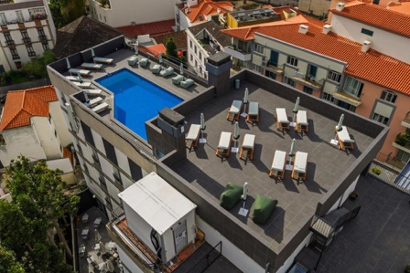
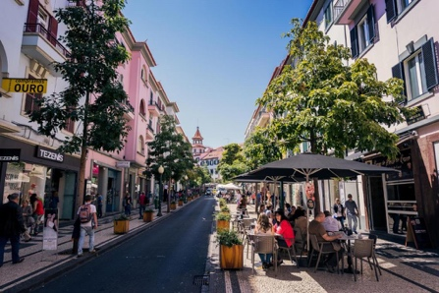
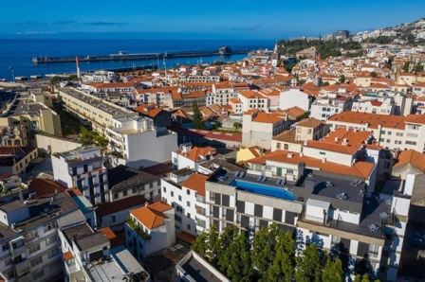
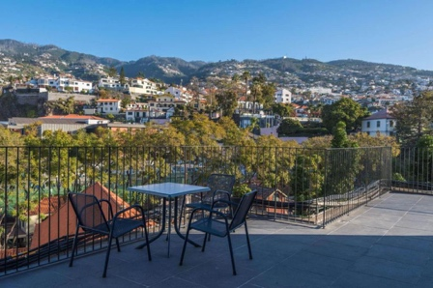
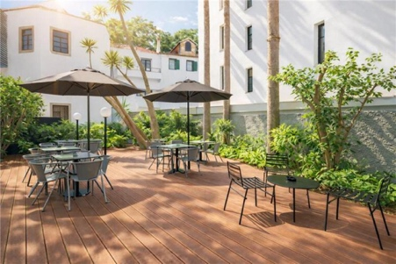
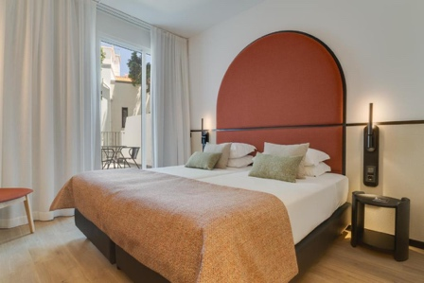

MADEIRA IN SUMMER
Discover an island where summer is all about nature, tradition and unforgettable experiences
Madeira is a destination that delights visitors throughout the year, but it truly comes to life during the summer. With pleasant temperatures, lush landscapes, a wide variety of outdoor activities and a calendar full of cultural events, the island offers the perfect setting for a memorable getaway. From Funchal to the natural swimming pools of Porto Moniz, from the trails of the Laurissilva Forest to the dramatic cliffs overlooking the Atlantic, every day is an invitation to discover an authentic Madeira, where nature, gastronomy and tradition come together. To experience all this in comfort and with a privileged location, we recommend the Summer Getaway at The Editory Garden Carmo Funchal, a programme designed for travellers who wish to discover the island at their own pace while enjoying every comfort.

10 Reasons to Visit Madeira in Summer
- Perfect Weather for Exploring: With mild temperatures and long sunny days, summer is the ideal season to discover Madeira without the extreme heat experienced in many Mediterranean destinations.
- Nature at Its Best: Madeira is home to mountains, valleys, dramatic cliffs, botanical gardens and the UNESCO-listed Laurissilva Forest, creating spectacular scenery wherever you go.
- Walking Trails for Every Level: The famous levada walks take visitors through some of the island's most beautiful landscapes, passing waterfalls, natural tunnels and breathtaking viewpoints.
- Natural Swimming Pools and Atlantic Coast: The volcanic natural pools of Porto Moniz, the golden sandy beaches of Calheta and Machico, and the island's dramatic coastline offer unforgettable seaside experiences.
- Breathtaking Viewpoints: From Cabo Girão to Pico do Areeiro and Ponta de São Lourenço, Madeira boasts some of Portugal's most spectacular panoramic views.
- A Vibrant Funchal: Explore the Old Town, visit the Farmers' Market, discover the tropical gardens, the marina and Santa Maria Street, famous for its painted doors.
- Ocean Experiences: Catamaran cruises, whale and dolphin watching, diving, kayaking and stand-up paddleboarding offer a unique way to discover the island from the Atlantic.
- Authentic Flavours: From traditional beef skewers cooked on bay laurel sticks and bolo do caco to black scabbardfish with banana, poncha and the world-famous Madeira Wine, the island's gastronomy is one of the highlights of any visit.
- A Summer Full of Traditions: Throughout the summer months, Madeira comes alive with traditional festivals, local celebrations and cultural events that offer visitors an authentic insight into the island's heritage.
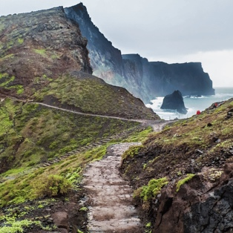
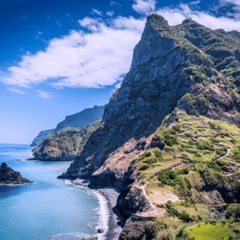
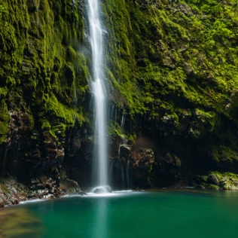
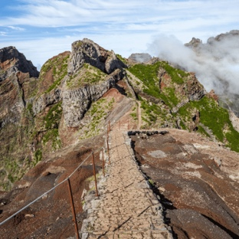
- A Destination for Everyone: Whether for a romantic escape, a family holiday or a journey of discovery, Madeira brings together nature, culture, adventure and comfort in one exceptional destination.

Madeira Wine Festival
If your trip takes place between late August and early September, there is one experience that deserves a special place in your itinerary. The Madeira Wine Festival celebrates one of the island's greatest traditions through grape harvest re-enactments, traditional grape treading, wine tastings, folk performances, parades and gastronomic experiences. More than just an event, it is an opportunity to experience Madeiran culture first-hand and discover the history of one of the world's most renowned fortified wines. For travellers seeking an even more authentic experience, this celebration adds a truly distinctive element to their journey.

Discover more about Madeira Wine Festival: https://www.youtube.com/watch?v=vB8WLkhmjRw
699€
Price from:

Price per person / in euros (EUR) / NET / VAT inc

SUGGESTIONS
Extend Your Journey in Portugal: As your journey to Madeira begins in either Lisbon or Porto, why not take the opportunity to explore one of Portugal's most iconic cities before or after your island escape?
Lisbon
Portugal's capital is a vibrant city where tradition meets modernity. From the historic neighbourhoods of Alfama, Baixa and Belém to the iconic yellow trams and panoramic viewpoints overlooking the Tagus River, Lisbon offers a unique blend of heritage, culture and gastronomy. Whether exploring UNESCO World Heritage Sites, enjoying the lively riverside atmosphere or experiencing the city's renowned culinary scene, every visit reveals a new side of Portugal.
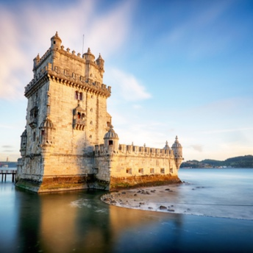
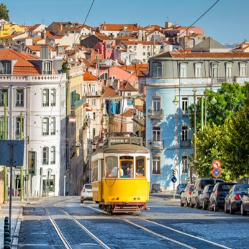
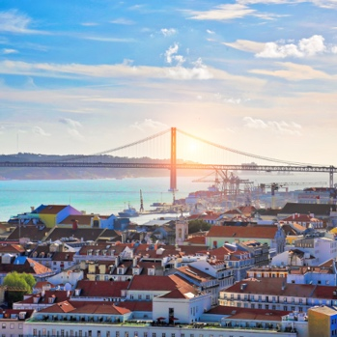

Porto
Located in northern Portugal, Porto is celebrated for its historic charm, colourful riverside and world-famous Port Wine. Its UNESCO-listed historic centre, elegant architecture and welcoming atmosphere make it one of the country's most distinctive destinations. Wander through its picturesque streets, admire the iconic Dom Luís I Bridge, visit the historic Port Wine cellars of Vila Nova de Gaia or enjoy a relaxing cruise along the Douro River while discovering the city's rich cultural heritage.
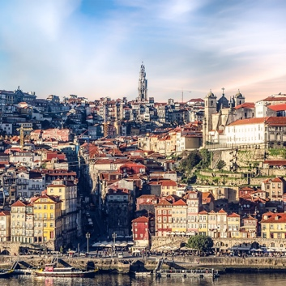
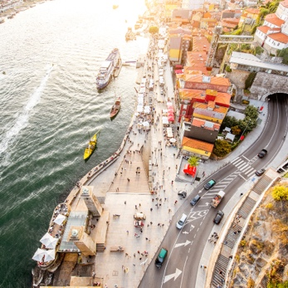
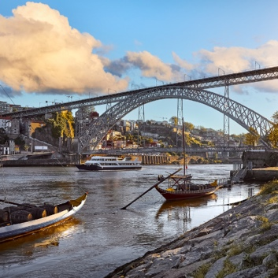

INCLUDED
- Return flights from Porto or Lisbon to Funchal and back with TAP Air Portugal in G Class (Low Season), including one checked bag of up to 23 kg per person.
- 5-day / 4-night stay in a Standard Double Room, including breakfast.
- Arrival and departure airport transfers.
NOT INCLUDED
- Booking fee.
- Flight supplement for travel between 1 July and 31 August, and between 1 and 31 October.
- Municipal Tourist Tax, payable locally.
- Personal expenses and any services not specifically mentioned.

GENERAL CONDITIONS
- Special offer; rates and availability must be confirmed at booking.
- Offer subject to limited availability of stock and services.
- If unavailable, an equivalent alternative will be proposed, pending client approval.
- Valid until travel date or while availability lasts.
- Full prepayment required at time of booking.
- Free cancellation up to 15 days before departure; non-refundable thereafter.
- Pricing based on the indicated number of participants; changes may affect total cost.
- HighSun is not liable for unfulfilled activities due to weather or external factors.





