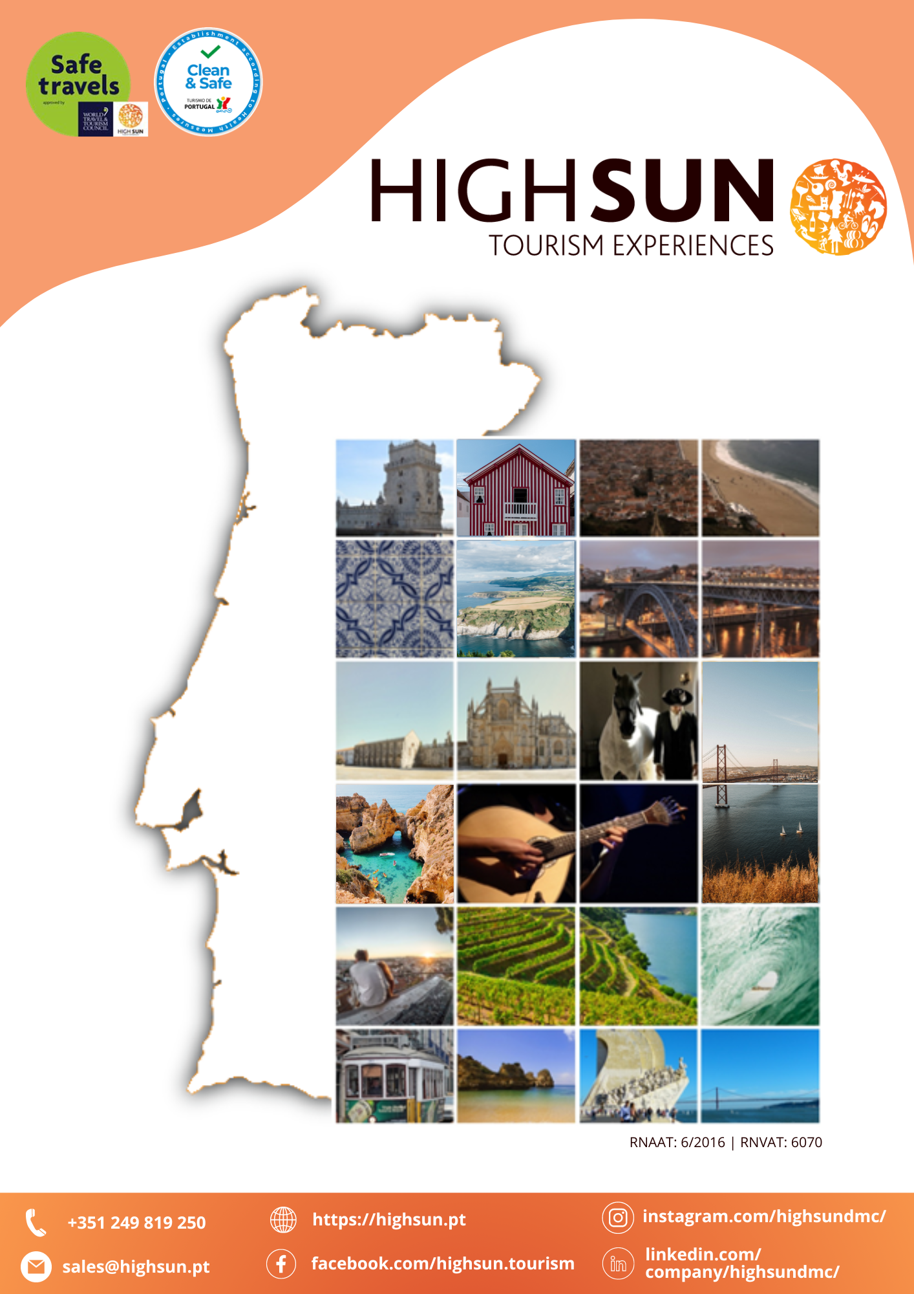
Proposal

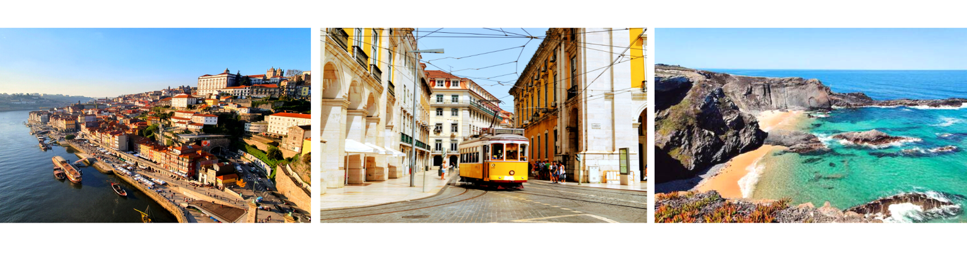

TASTE OF AZORES (São Miguel Island)

This suggested short-stay itinerary offers the perfect introduction to São Miguel, the largest island of the Azores.
Over the course of 4 nights, you'll experience a carefully balanced mix of cultural discovery, local insight, and natural beauty—guided at times by expert locals, and at others left free to explore at your own pace. From unforgettable landscapes and unique traditions to moments of pure tranquility, this program is designed to make the most of a brief but enriching escape from everyday life.

Day 1 – Azores – Ponta Delgada
Arrival at Ponta Delgada Airport, the gateway to São Miguel, the largest and most diverse island in the Azores archipelago. São Miguel offers an abundance of activities for all types of travelers, from scenic hikes through lush landscapes to cultural experiences and natural hot springs. A private transfer will take you to your chosen hotel in Ponta Delgada, the island's vibrant capital.
The rest of the day is free for you to relax and explore at your own pace.
Overnight at the hotel.

Day 2 – Azores – Ponta Delgada
Breakfast at the hotel.
Embark on a Full-Day Guided Hiking Tour to the stunning Lagoa do Fogo, one of São Miguel’s most breathtaking natural wonders.
This hiking tour takes you through São Miguel’s lush landscapes, volcanic peaks, and crystal-clear lakes. Lagoa do Fogo, located in the heart of the island, is a protected nature reserve, renowned for its dramatic beauty and unique flora.
Along the way, you’ll explore scenic trails that offer panoramic views of the surrounding area and a deeper connection to the island's volcanic heritage. São Miguel offers a wide variety of hiking paths, from coastal tracks to higher altitudes, ensuring an unforgettable experience for nature enthusiasts and adventure seekers.
Enjoy the rest of the day free at leisure.

Day 3 – Azores – Ponta Delgada
Breakfast at the hotel.
Today, set out on an unforgettable whale watching tour—one of the most iconic experiences in the Azores. Thanks to the archipelago’s unique location in the North Atlantic, around 24 species of cetaceans can be spotted throughout the year.
Accompanied by experienced skippers, marine biologists, and lookouts, you'll venture out to sea aboard a semi-rigid or cabin boat (depending on group size). The crew adheres to a strict code of ethics for responsible wildlife observation, ensuring both a respectful and enriching encounter. All necessary safety and comfort equipment will be provided for a memorable experience on the Atlantic waters.
Enjoy the rest of the day free at leisure.

Day 4 – Azores – Ponta Delgada
Breakfast at the hotel.
Option A: Enjoy a regular Half-Day Jeep Tour through the stunning landscapes of Sete Cidades, one of São Miguel Island’s most iconic natural wonders. With panoramic 360º views from the vehicle, you'll explore crater lakes, lush valleys, and scenic lookouts in a fun and adventurous way.
This guided tour offers a memorable introduction to the island’s volcanic beauty, taking you to key viewpoints and hidden spots around the legendary blue and green lakes of Sete Cidades.
Option B: Embark on a Half-Day Guided Hiking Tour to the stunning Salto do Cabrito, one of São Miguel’s most iconic trails.
Part of the official Azores Walking Trails network, this route highlights the island’s lush interior landscapes, striking waterfalls, and volcanic heritage. São Miguel alone features 29 classified trails, offering countless opportunities to explore its diverse terrain—from coastal paths to mountainous tracks.
Option C: Enjoy your free day exploring São Miguel at your own pace. Whether you choose to stroll through lively local towns, unwind by the ocean, or venture into the island’s lush volcanic landscapes, this is your time to discover the natural beauty and charm of the Azores' largest island.

Day 5 – Azores – Ponta Delgada
Breakfast at the hotel and check-out. Enjoy a leisurely morning for some last-minute shopping or to explore the charming streets, local markets, and seafront of Ponta Delgada, the main city of São Miguel, Azores. At the scheduled time, a private transfer will take you to Ponta Delgada Airport for your return flight. Say farewell to the island—with the feeling that you’ll be back again soon!

Included
- 4 nights accommodation at chosen hotel in double occupancy with breakfast;
- Private arrival and departure transfers;
- Full-day private hiking guided tour to Lagoa do Fogo and Furnas, including picnic lunch;
- Boat tour for cetacean observation.

Not Included
- Suggestions mentioned in the itinerary;
- Rent-a-car;
- City taxes;
- Flights and visas;
- Personal expenses;
- Any items or services not explicitly mentioned as included.

BUDGET
Hotel | Season
Hotel | 01.05.2025 - 31.10.2025 | 01.11.2025 – 31.03.2026
NEAT Hotel Avenida  3* | 549€ | 479€
Hotel Vila Galé Collection São Miguel  4* | 691€ | 538€
Octant Hotels Ponta Delgada  5* | 1139€ | 714€
Price per person / in euros (€) / NET / With VAT
Note: Based on a minimum of 2 people in a double room. If the hotel listed in the selected category is unavailable, an equivalent or superior alternative will be provided.
OPTIONALS
Half Day Jeep Tour to Sete Cidades Lagoon | 45€  Per Person
Half-Day Guided Hiking Tour to Salto do Cabrito | 50€  Per Person

GENERAL CONDITIONS

- This is a proposal only; no reservations have been made. Upon booking, the availability of all proposed services must be confirmed. If any service is unavailable, a suitable alternative will be offered for approval.
- HighSun reserves the right to modify the program or itinerary (including hotels, activities, restaurants, services, etc.) without entitlement to compensation, due to external factors such as bad weather, venue maintenance/closures, scheduling conflicts, etc. In such cases, HighSun will, where possible, offer a similar alternative experience.

